MobileTestingScenario_runTestScenario_Instance3_06-Apr-2016_08-17-09_AM_Staging_Page_Navigation.png

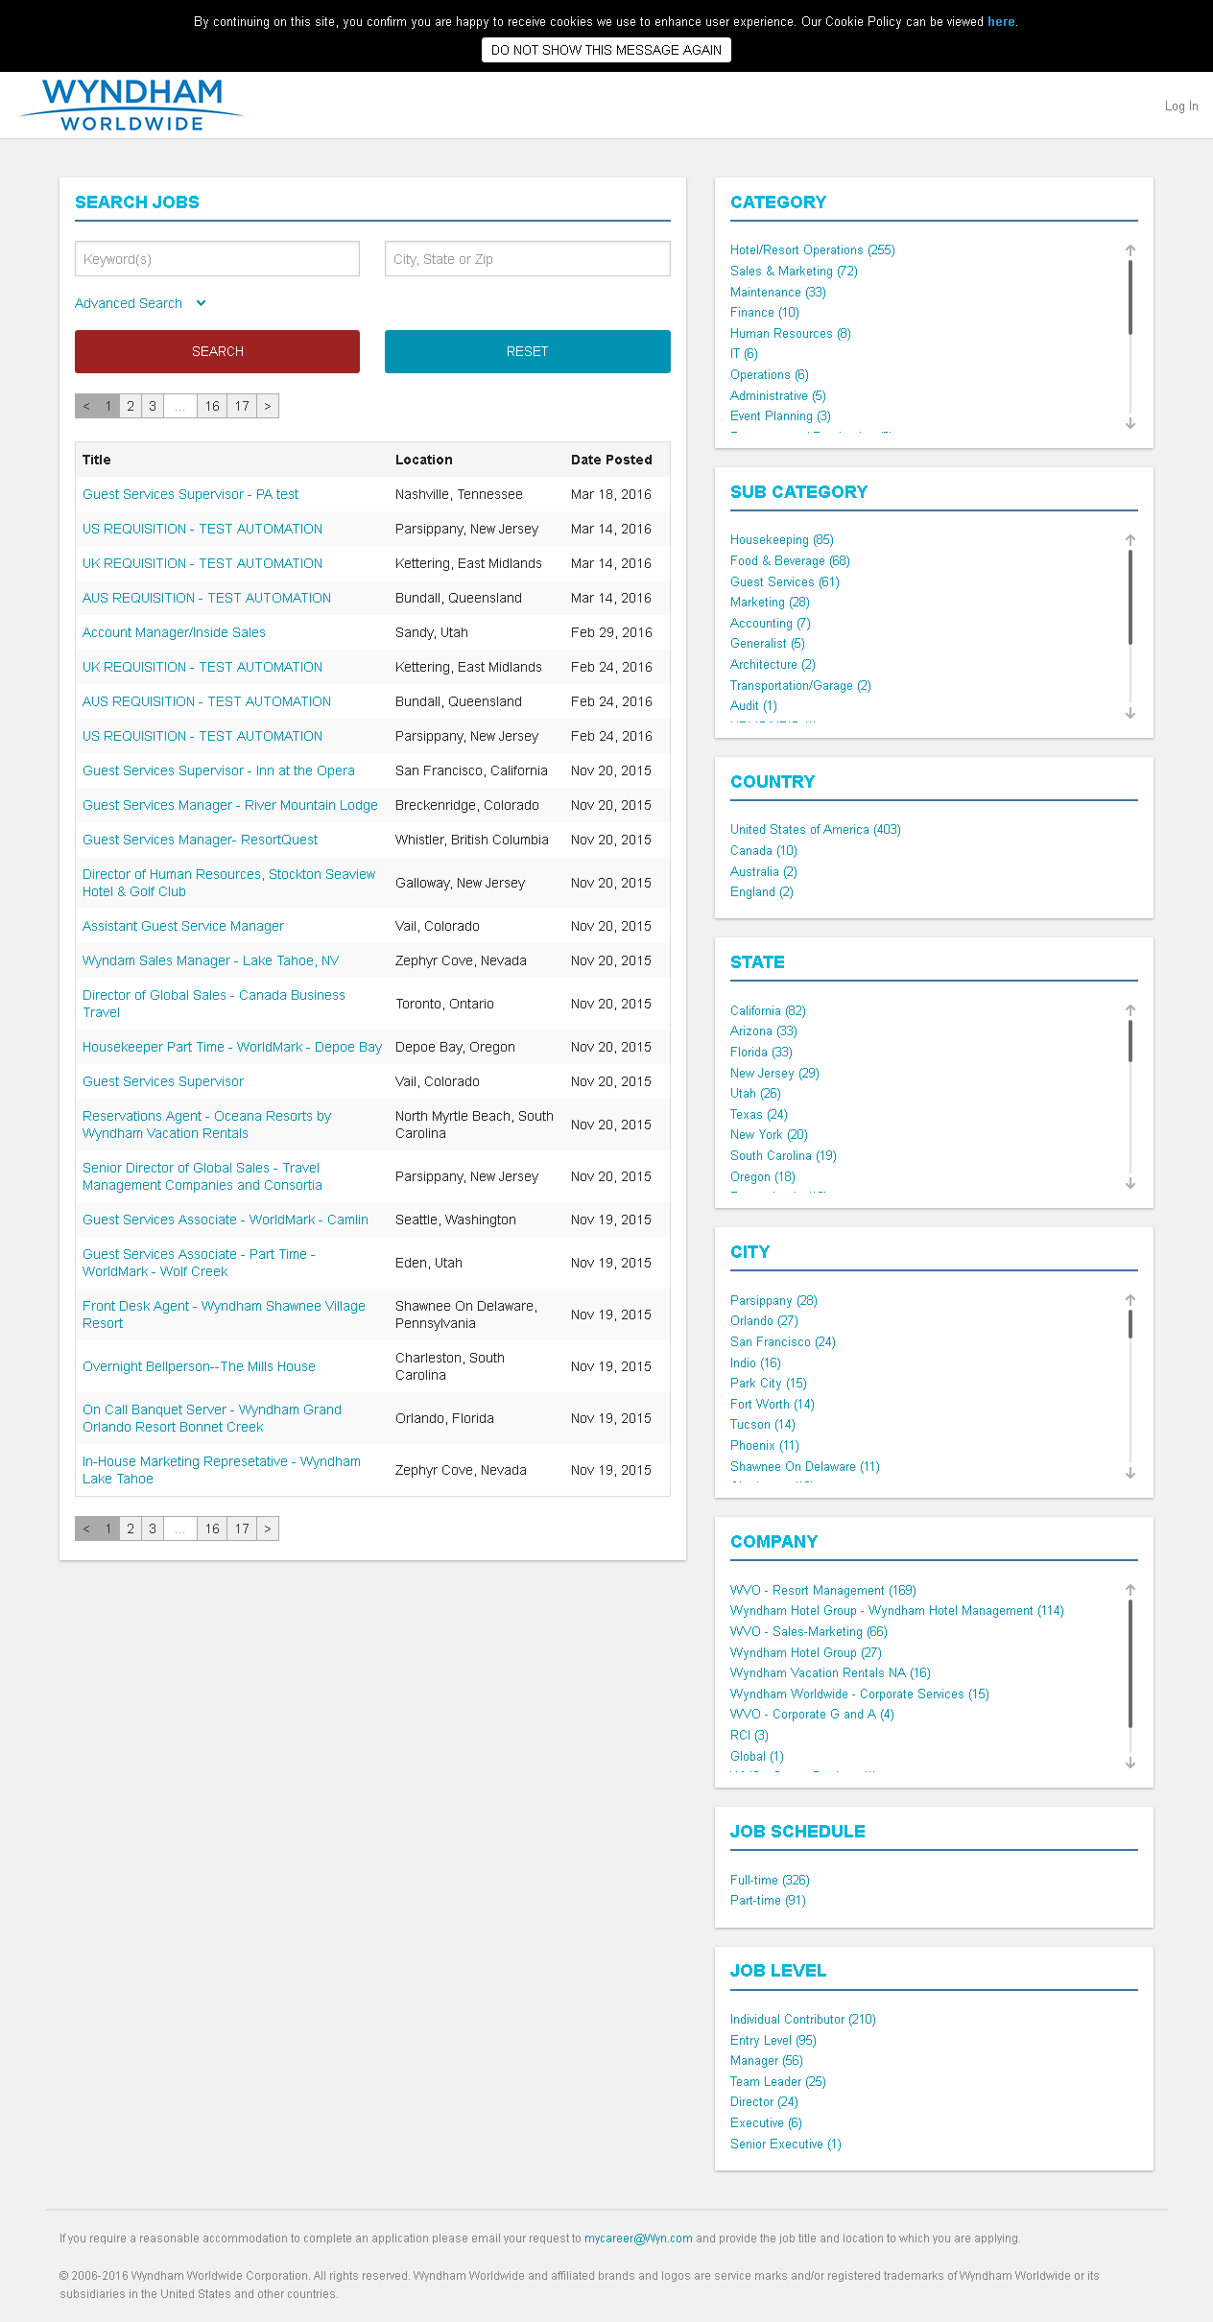

MobileTestingScenario_runTestScenario_Instance3_06-Apr-2016_08-17-48_AM_Create_Account.png

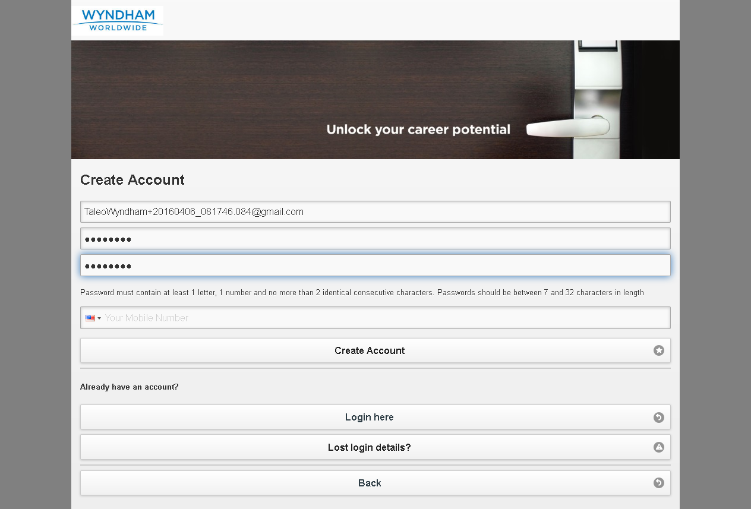

MobileTestingScenario_runTestScenario_Instance3_06-Apr-2016_08-18-08_AM_Create_Account.png

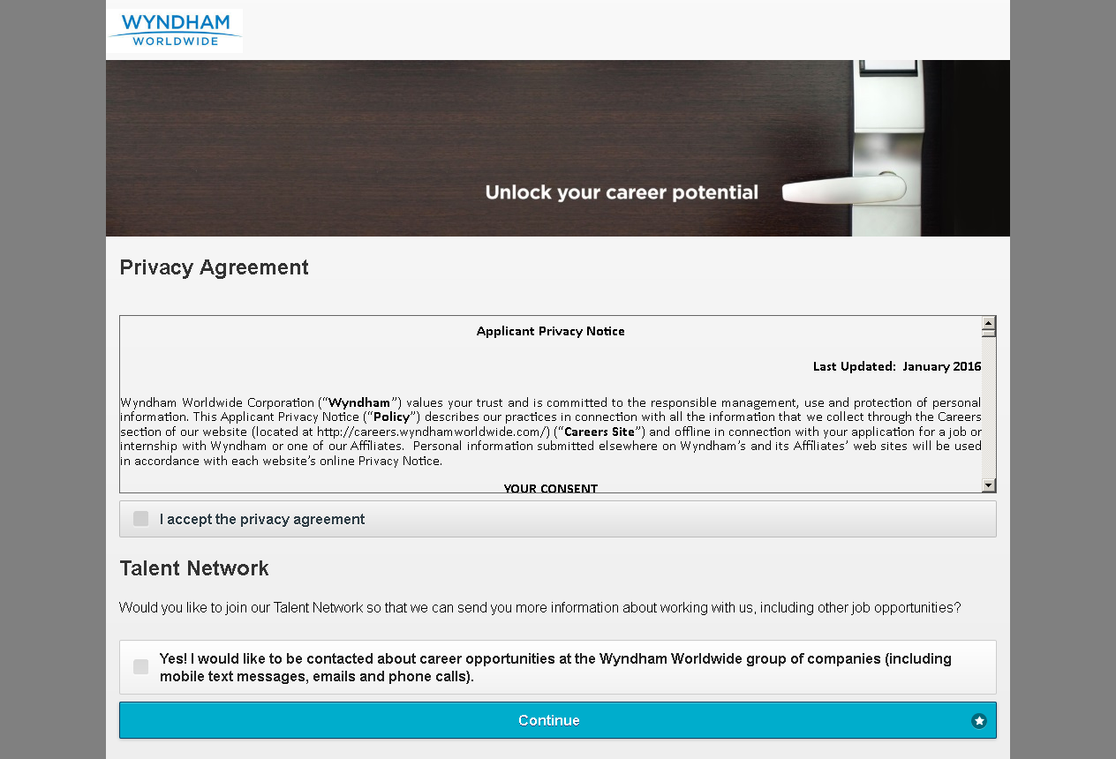

MobileTestingScenario_runTestScenario_Instance3_06-Apr-2016_08-18-09_AM_Continue.png



MobileTestingScenario_runTestScenario_Instance3_06-Apr-2016_08-18-14_AM_privacyAgreement.png

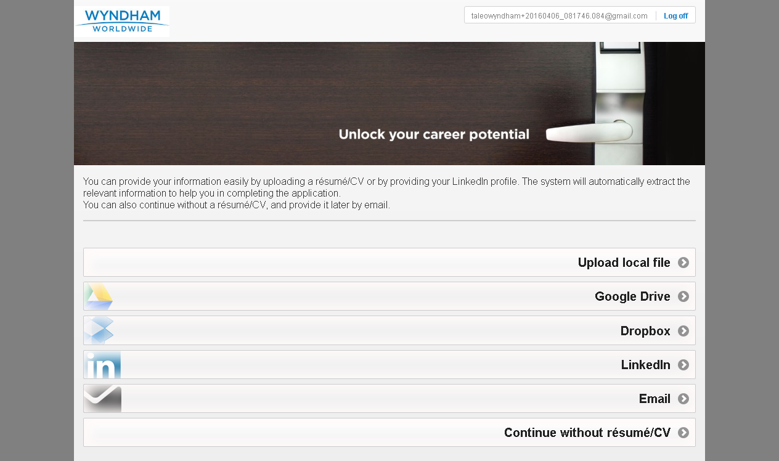

MobileTestingScenario_runTestScenario_Instance3_06-Apr-2016_08-18-14_AM_Resume_Option.png



MobileTestingScenario_runTestScenario_Instance3_06-Apr-2016_08-18-22_AM_Dropbox_Option.png

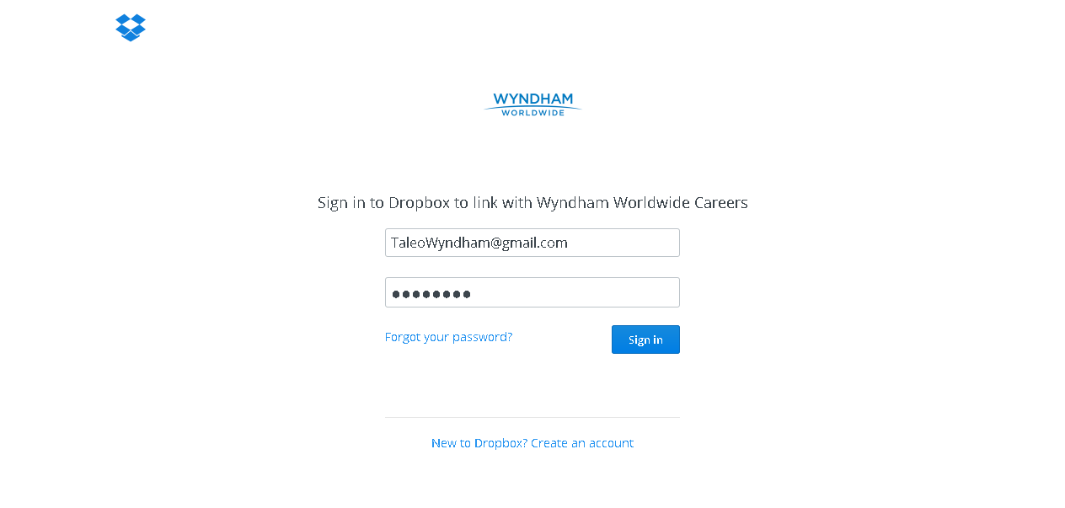

MobileTestingScenario_runTestScenario_Instance3_06-Apr-2016_08-18-35_AM_Dropbox_Option.png

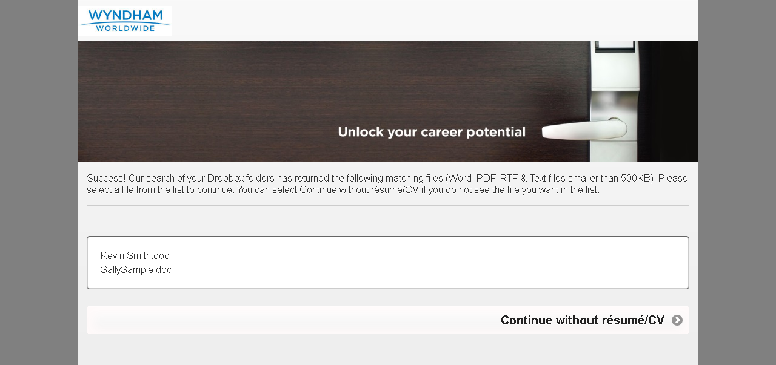

MobileTestingScenario_runTestScenario_Instance3_06-Apr-2016_08-18-40_AM_Dropbox_Option.png

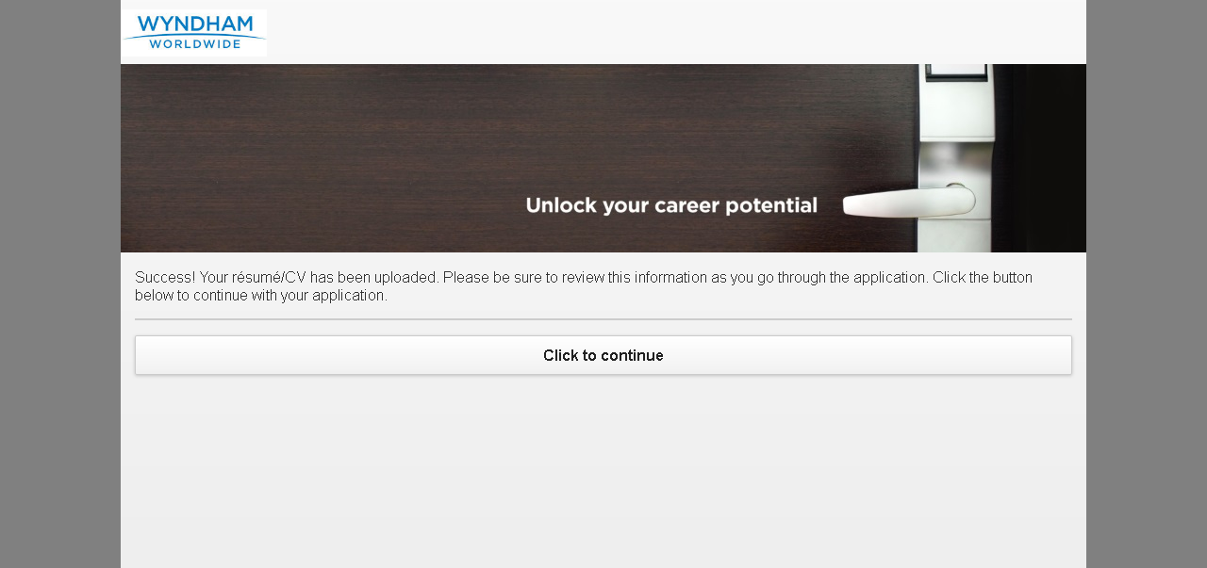

MobileTestingScenario_runTestScenario_Instance3_06-Apr-2016_08-19-23_AM_Tell_us_about_yourself.png

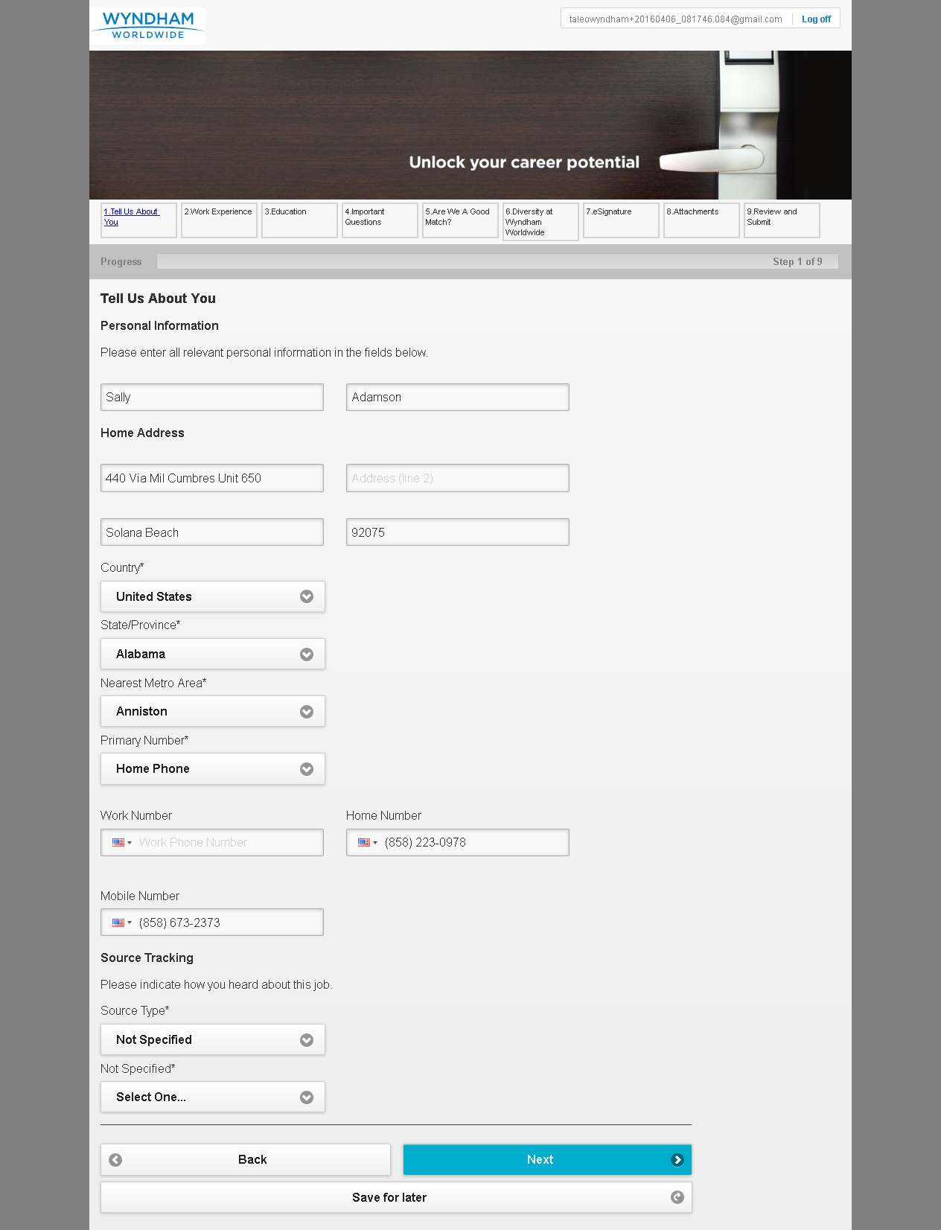

MobileTestingScenario_runTestScenario_Instance3_06-Apr-2016_08-19-34_AM_Tell_us_about_yourself.png

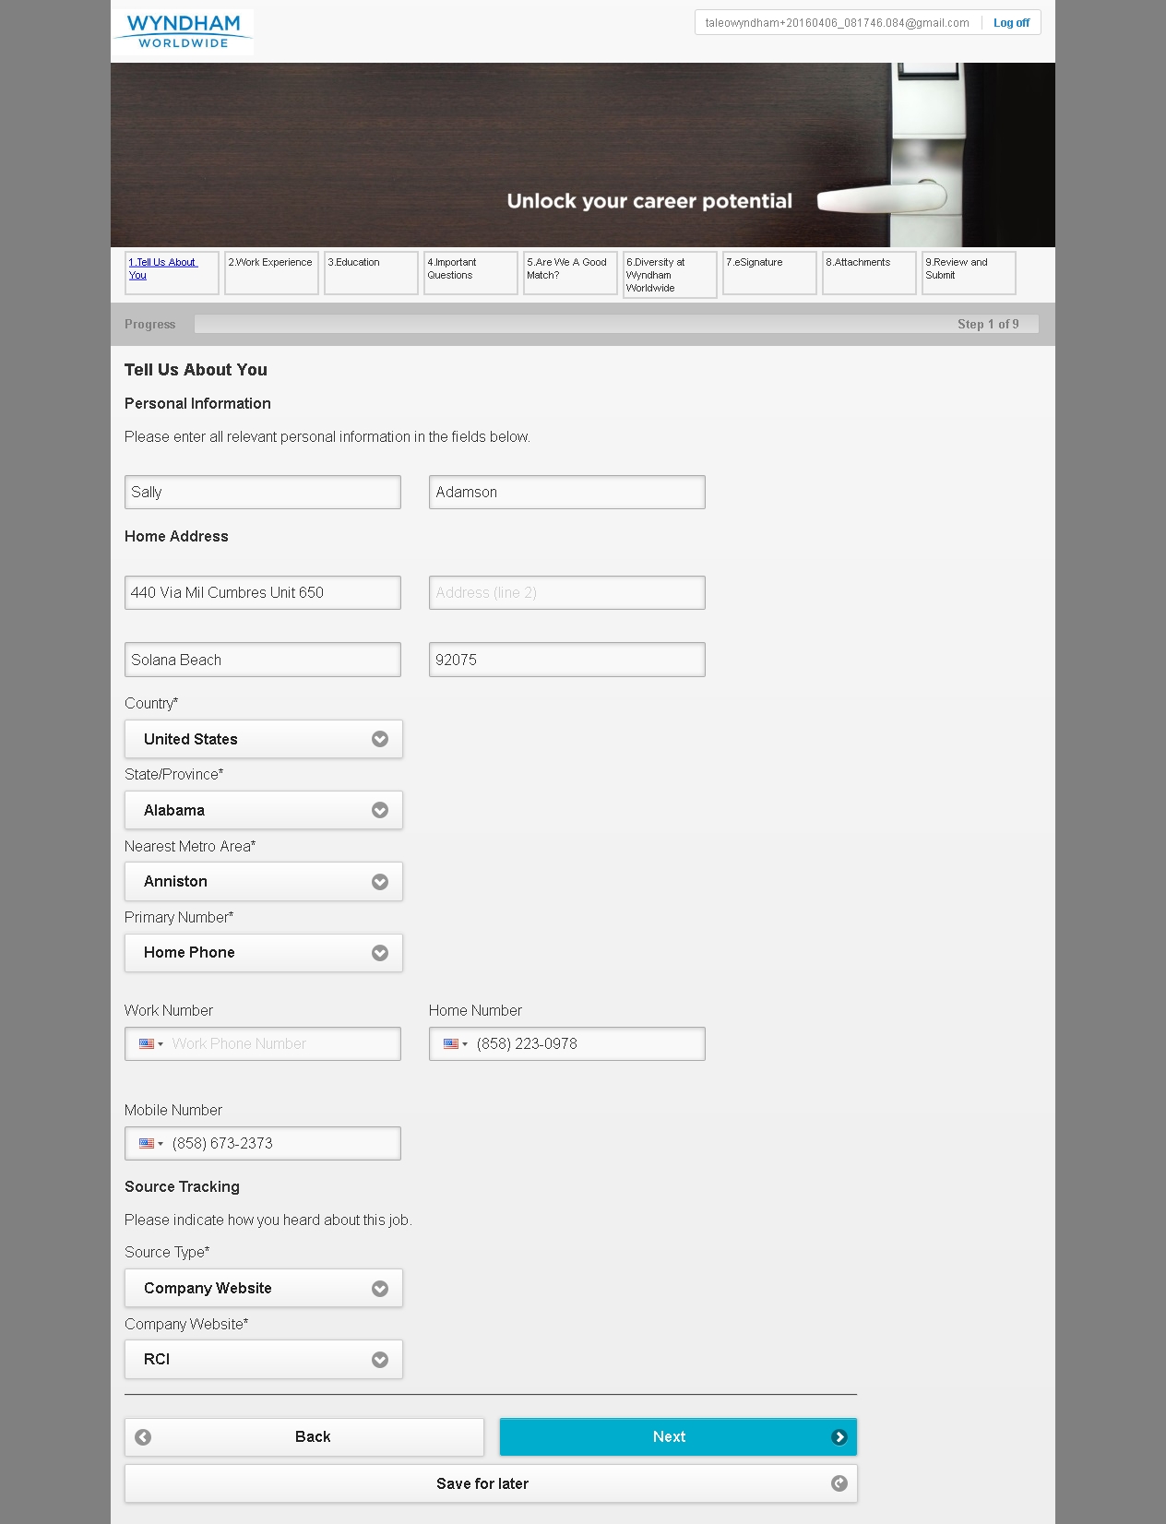

MobileTestingScenario_runTestScenario_Instance3_06-Apr-2016_08-19-48_AM_Work_Experience.png

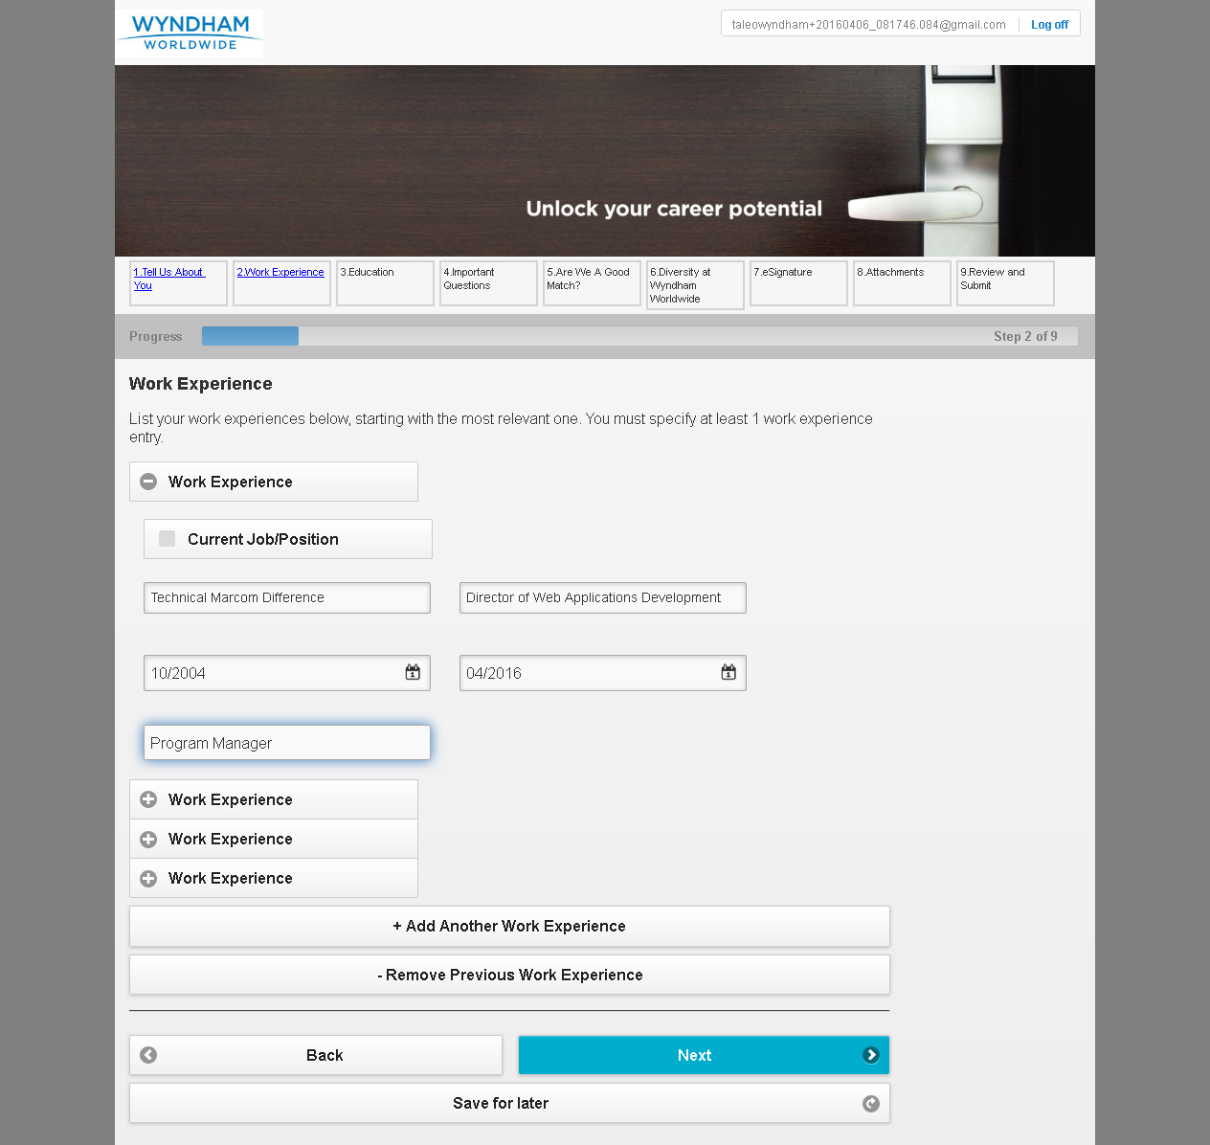

MobileTestingScenario_runTestScenario_Instance3_06-Apr-2016_08-20-05_AM_Education.png

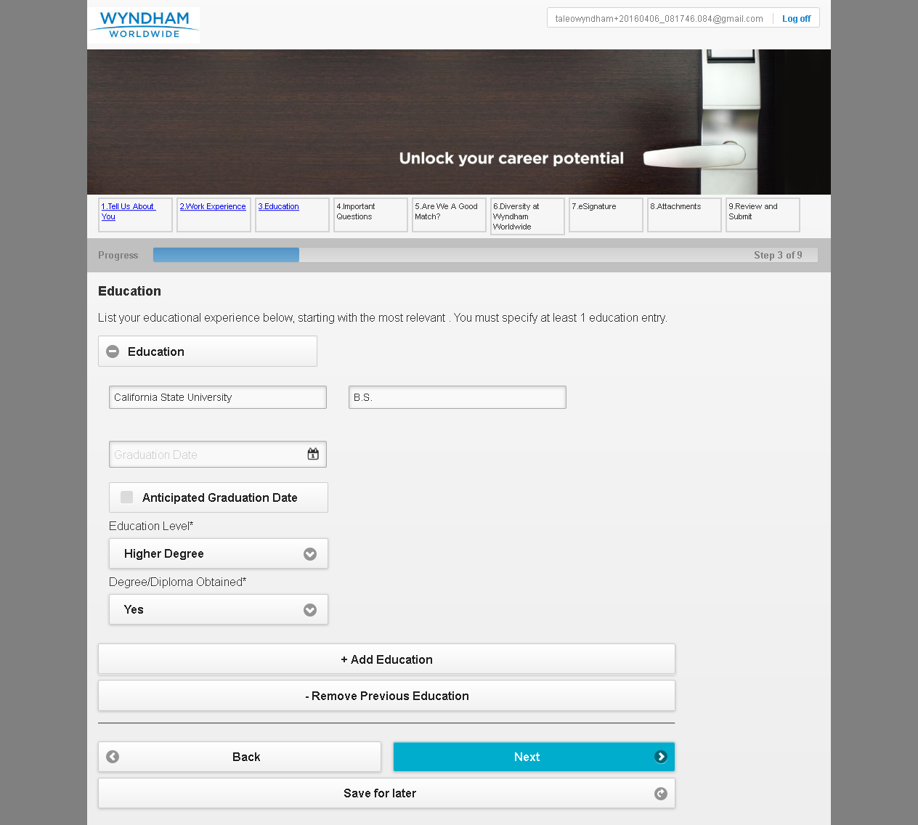

MobileTestingScenario_runTestScenario_Instance3_06-Apr-2016_08-20-12_AM_Questions.png

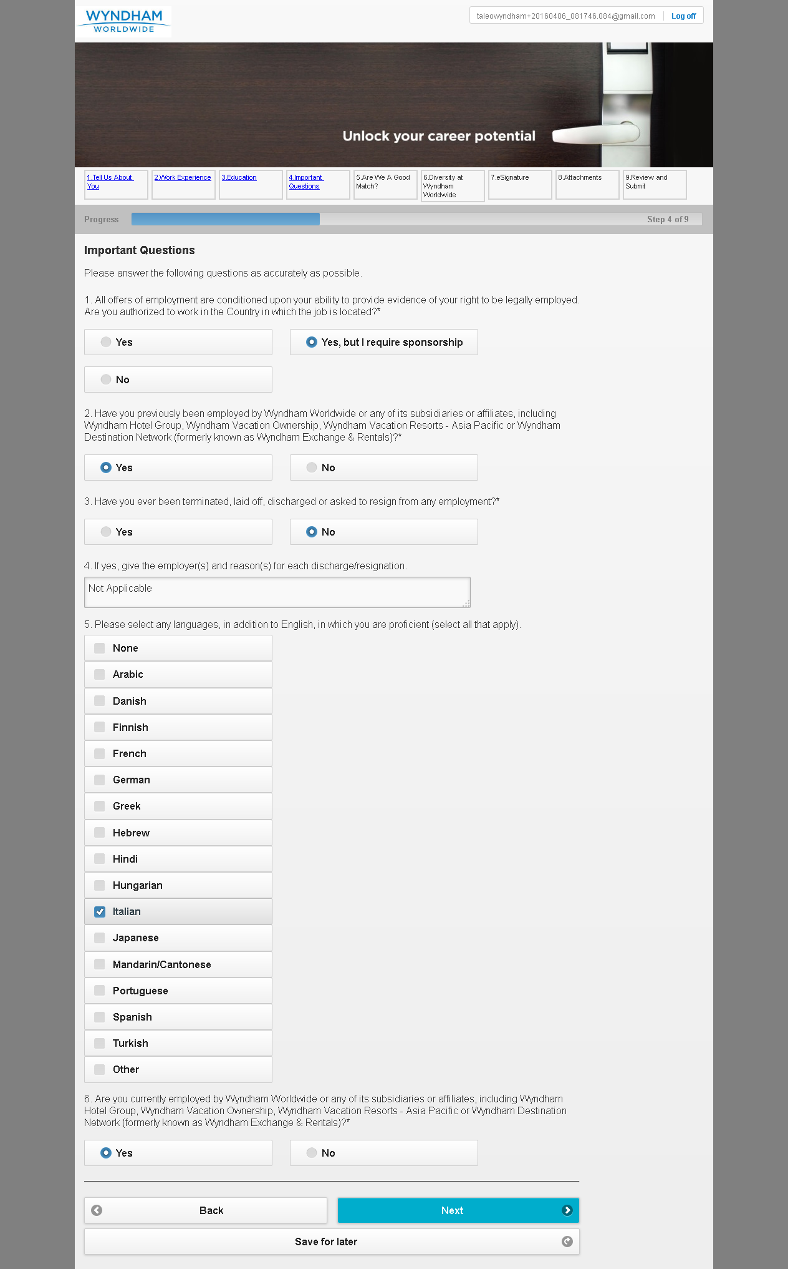

MobileTestingScenario_runTestScenario_Instance3_06-Apr-2016_08-20-20_AM_Are_we_good_Match.png

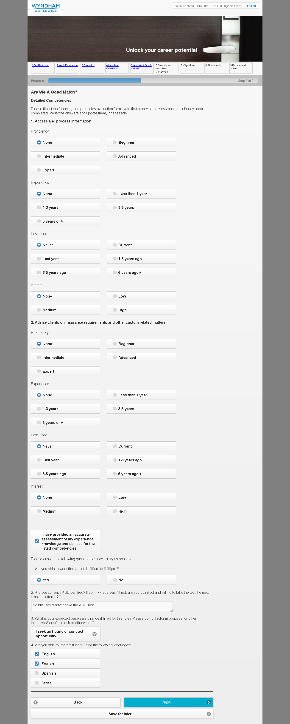

MobileTestingScenario_runTestScenario_Instance3_06-Apr-2016_08-20-43_AM_Diversity.png

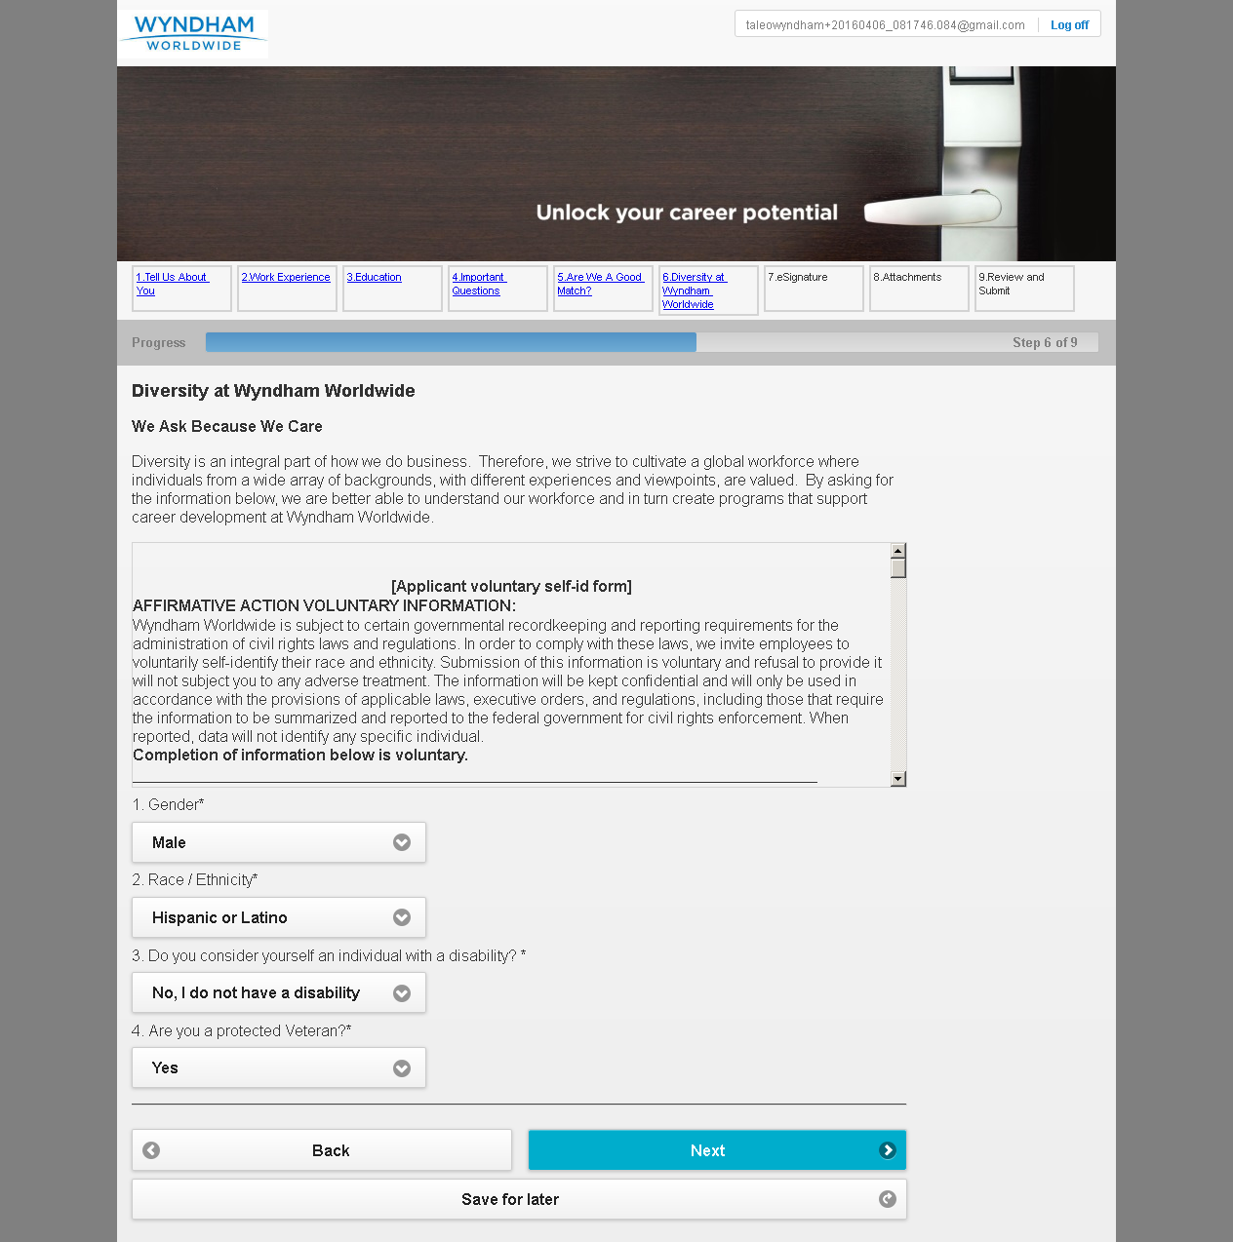

MobileTestingScenario_runTestScenario_Instance3_06-Apr-2016_08-20-51_AM_eSignature.png

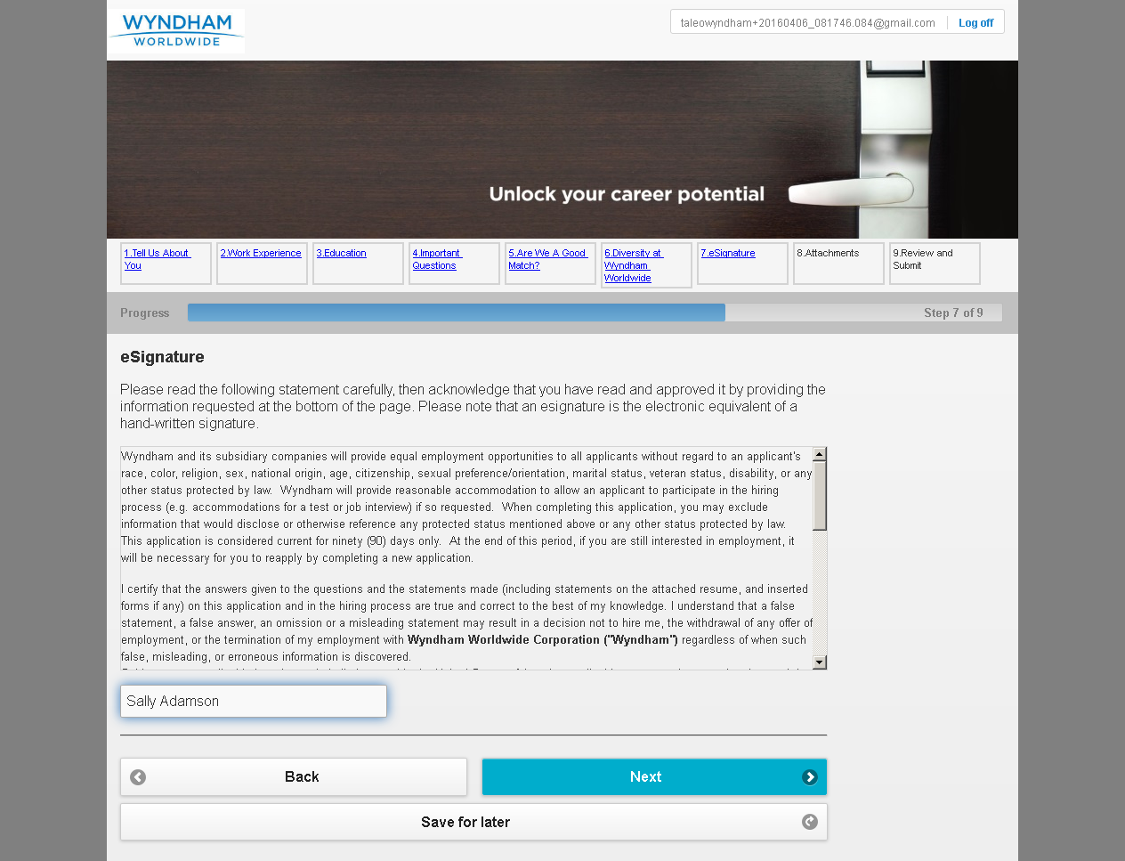

MobileTestingScenario_runTestScenario_Instance3_06-Apr-2016_08-20-58_AM_Attachment.png

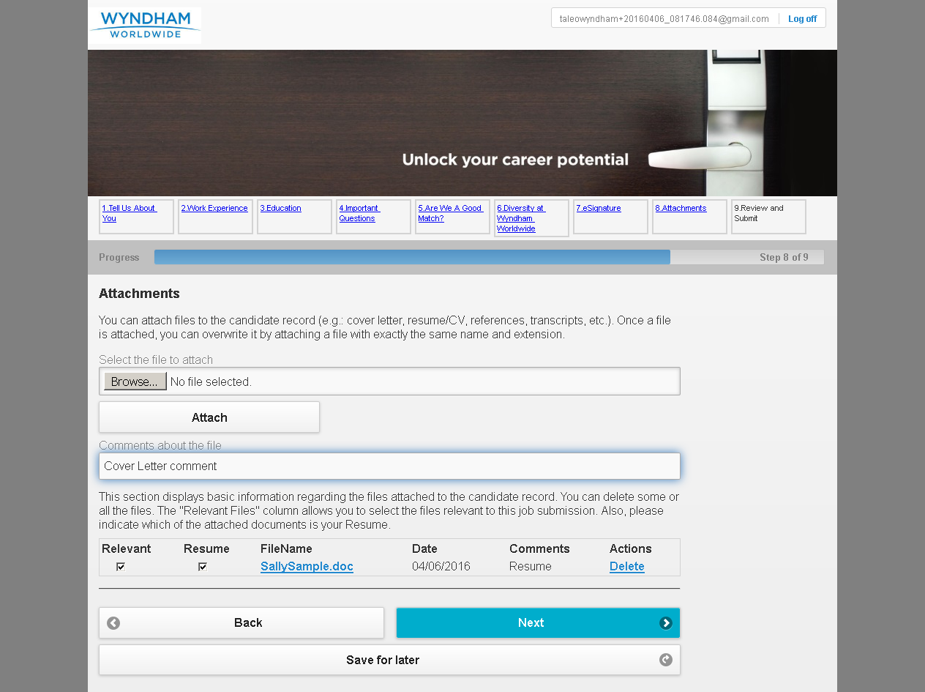

MobileTestingScenario_runTestScenario_Instance3_06-Apr-2016_08-21-09_AM_Review_and_Submit.png

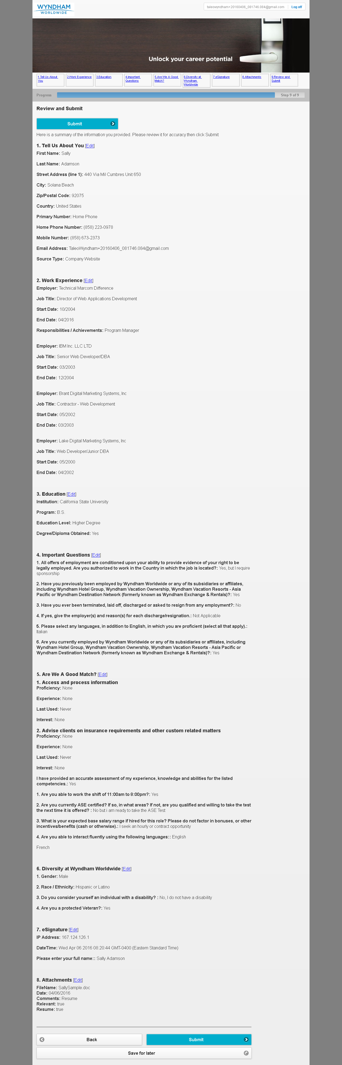

MobileTestingScenario_runTestScenario_Instance3_06-Apr-2016_08-21-20_AM_Application_Completed.png

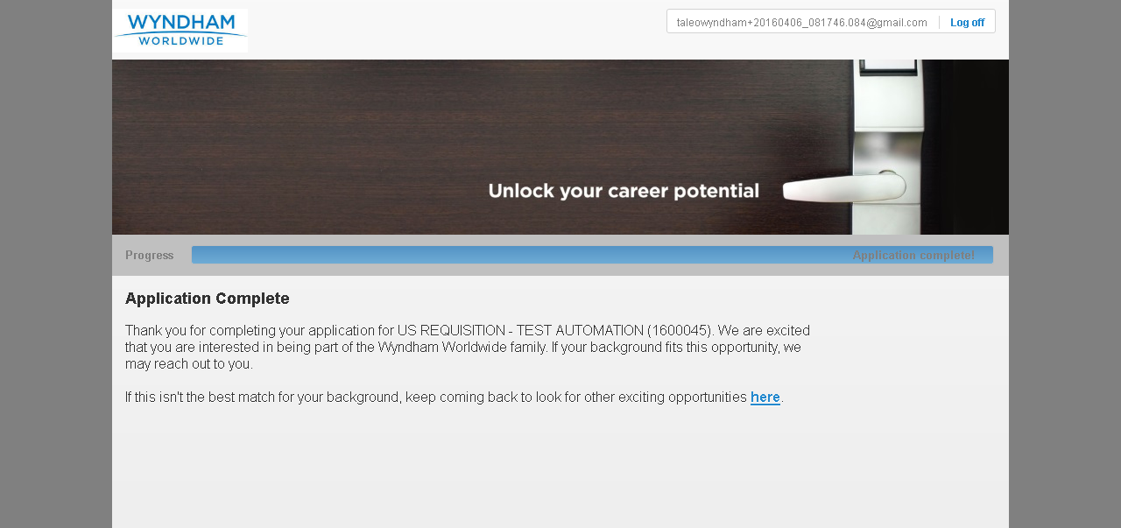

MobileTestingScenario_runTestScenario_Instance3_06-Apr-2016_08-21-31_AM_CRM_Loop_Validation.png

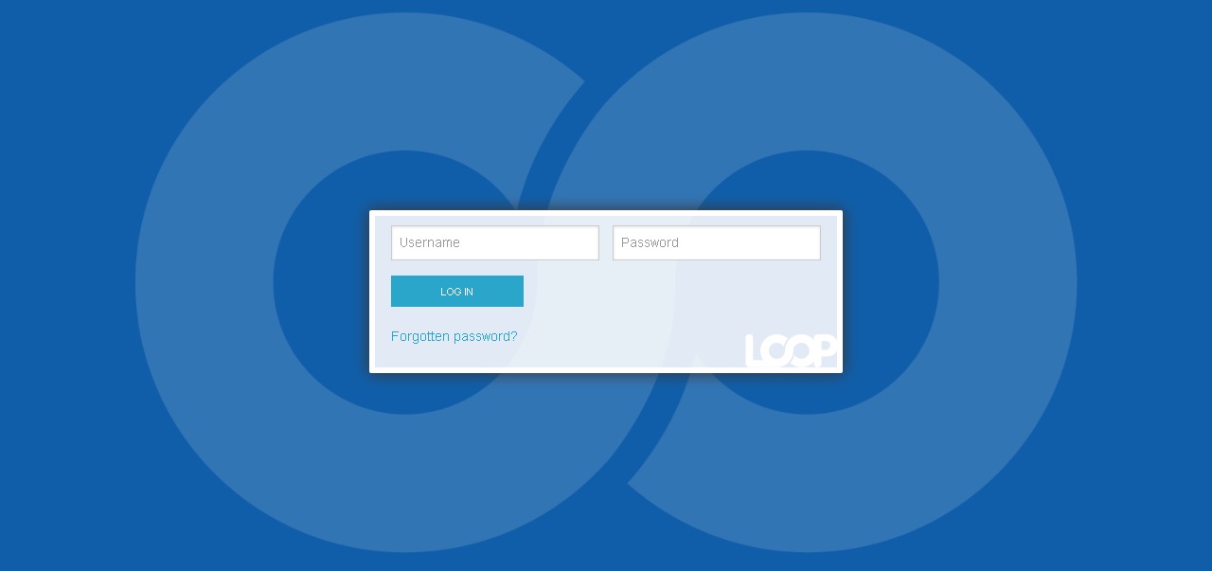

MobileTestingScenario_runTestScenario_Instance3_06-Apr-2016_08-21-38_AM_CRM_Loop_Validation.png

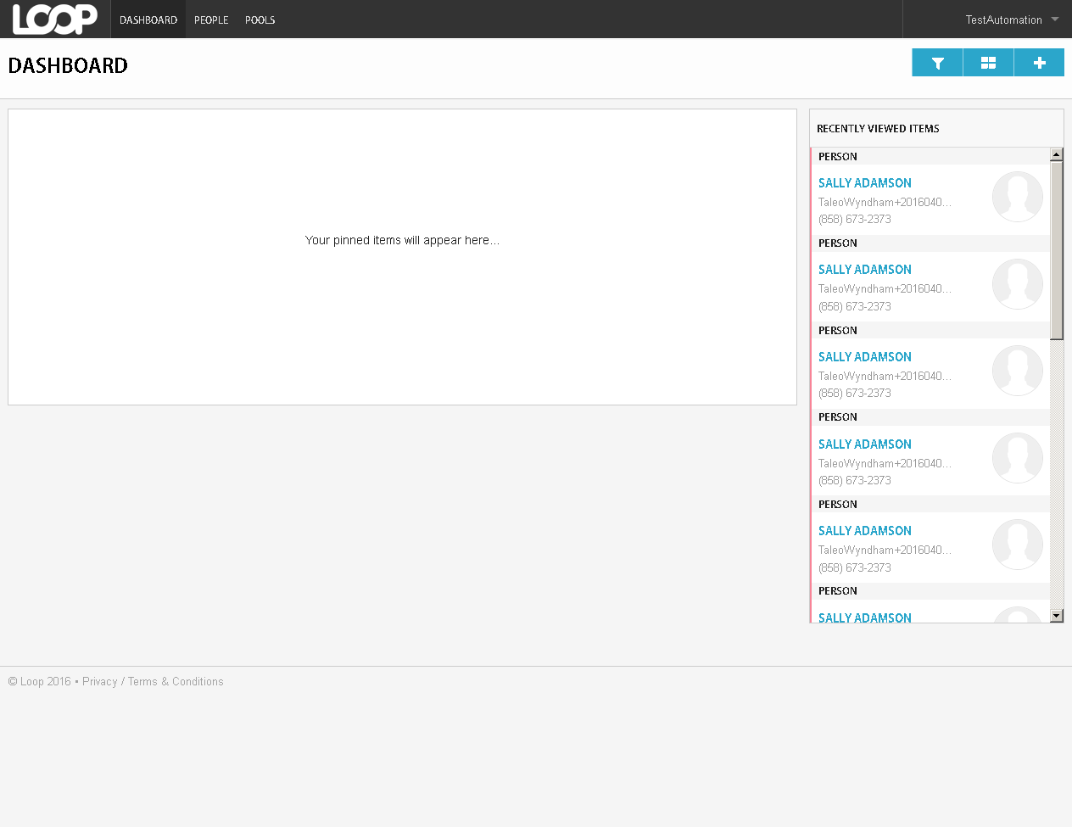

MobileTestingScenario_runTestScenario_Instance3_06-Apr-2016_08-21-59_AM_CRM_Loop_Validation.png

